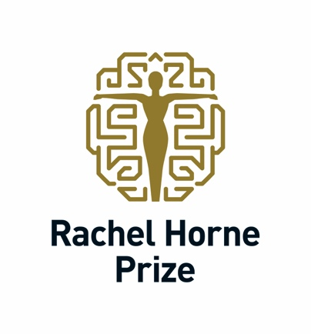

APPLICATIONS OPEN FOR PRESTIGIOUS INTERNATIONAL PRIZE TO RECOGNISE WOMEN SCIENTISTS AND NEUROLOGISTS IN MULTIPLE SCLEROSIS RESEARCH

Submissions for the 2024 Rachel Horne Prize for Women’s Research in MS are now open.

This year, the annual award of US$40,000 will honour a female scientist whose exceptional clinical research work has improved patient care in women with multiple sclerosis (MS).

The Prize is intended for mid-to-senior career women MS scientists and neurologists. Applicants must have worked for more than 15 years at Assistant Professor level and, at the time of application, hold the title of Associate Professor or Professor. Applicants should identify as female. There are no specific requirements in respect of residency or citizenship.

Applications are to be submitted online by the applicant and should include a CV and a Letter of Reference, describing why the applicant is suitable for the prize. Previous applicants are welcome to re-submit their entry with an updated reference.

Full details of the application process can be found by registering on the online application portal. The deadline for submitting applications is 11 June 2024.

The review panel will include members of International Women in MS. The winner will be presented with the award at the 40th Congress of the European Committee for Treatment and Research in Multiple Sclerosis (ECTRIMS) in Copenhagen, Denmark in September 2024.

The prize of US$40,000 is to be used at the discretion of the recipient. It is made possible by the generosity of the Horne Family Charitable Foundation and is supported by International Women in MS (iWiMS), ECTRIMS, and the Americas Committee for the Treatment and Research in MS (ACTRIMS).

“iWiMS is delighted to partner with the Rachel Horne Prize for Women’s Research in MS in recognising the important research women neuroscientists conduct that has improved clinical care of women with MS,” says Professor Emmanuelle Waubant, Chair of iWiMS and President-Elect of ACTRIMS. “For too long, women have been overlooked when it comes to rewarding their research into MS and the particular issues facing women with MS are often given insufficient attention.”

EDITOR’S NOTES

ONLINE PRESENCE
www.rachelhorneprize.com
@RachelHorne19 #RachelHornePrize #WomenInMSMatter
Rachel Horne

ABOUT RACHEL HORNE
Rachel Horne was diagnosed with multiple sclerosis in 2009. Drawing on her journalism background, she began researching the disease from a patient perspective and realised how little information existed about specific women’s health issues in MS – even though women make up two thirds of the people diagnosed with the disease.

She was also struck by how few women neurologists and scientists in MS were recognised for their research. In response, she set up the Rachel Horne Prize for Women’s Research in MS in 2022 through the Horne Family Charitable Foundation in Canada which was established by her father in 2010 “to do good in the world”.

ABOUT THE HORNE FAMILY CHARITABLE FOUNDATION
This prize, made possible by the generosity of the Horne Family Charitable Foundation, is to be used at the discretion of the recipient. The Horne family believes in the importance of philanthropy to shape our world. It was this belief which led Stuart Horne to set up the Horne Family Charitable Foundation following his death in 2010. The family foundation is administered by Aqueduct Foundation, which is based in Vancouver, Canada. Aqueduct is a cause-neutral Canadian registered charity with donor advised granting and specialized charitable programs in education, the arts and the environment.
www.aqueductfoundation.ca

ABOUT iWiMS
The International Women in Multiple Sclerosis (iWiMS) network unites clinicians and researchers committed to advancing scientific discoveries and improving care for people with MS and related disorders. Founded by women and supportive of all, iWiMS advocates for meritocracy, diversity, parity, and ingenuity in MS research and patient care.
www.iwims.world

ABOUT ECTRIMS
The European Committee for Treatment and Research in Multiple Sclerosis is a non-profit, independent, representative European-wide organisation that serves as Europe’s and the world’s largest professional organisation dedicated to the understanding and treatment of multiple sclerosis.
www.ectrims.eu

ABOUT ACTRIMS
Americas Committee for Treatment and Research in Multiple Sclerosis is a community of leaders from the United States and Canada who are dedicated to the treatment and research in MS and other demyelinating diseases. ACTRIMS focuses on knowledge dissemination, education and collaboration among disciplines.
www.actrims.org

